Chicken & Gravy

Mashed Potato

Peas

Steak & Cheese Sub

Steamed Broccoli

Fruit

**No School**

Bosco Sticks

Fruit

Salad Bar

Milk

Chef’s Choice

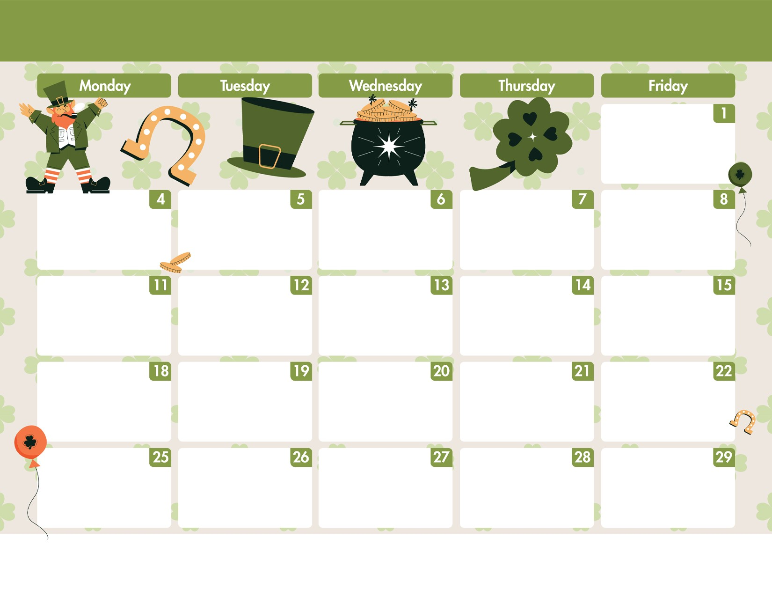

**MARCH**

**20**

**24**

Harpswell Elementary School

Spaghetti Meatball

w/Garlic Bread

Side/Broccoli Salad

Chicken Fingers

Baked Wedge

Fresh Fruit

Monte Cristo

Greek Pasta Salad

Strawberry Cup

Hotdogs

Fun Chips

Fresh Fruit

Baked Ziti

w/WG Roll

Pineapple

Beef Taco’s

Refried Beans

Fresh Fruit

Cheeseburgers

Veggies

Fruit Cup

Shepard’s Pie

W/Biscuit

Fresh Fruit

French Toast Sticks

w/Sausage

Peach Cup

Baked Ham & Cheese

Penne Pasta

Bread Stick

Fresh Fruit

Pizza Crunchers

Sun Chips

Applesauce Cup

BBQ Grilled Chicken

w/Fried Rice

Fresh Fruit

Menu is subject to change

without

notice

Sloppy Joe’s

Tater Tots

Fresh Fruit

Beef Mac & Cheese

w/Garlic Toast

Pear Cup

Broccoli & Cheddar Soup

w/Grilled Cheese

on Sour Dough Bread

Fresh Fruit

Sampler

Chicken Fries

Baked Cheese Sticks

Potato Wedges

Jello Cup

